Link to my Git repository

<https://github.com/Maneesha-Keloth/backendtest-cynaxlabs.git>

Q1.

Database structure for categories(Here I am using mongodb for data modelling)

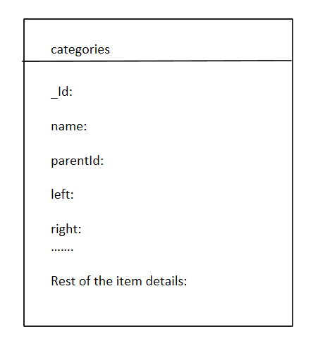

_id: id of the category document

Name: Name of the category

Left: left index for round trip traversal of the tree from the root

Right: right index for round trip traversal of the tree back to root

Write a query to fetch all the first-level children (categories+items) for a category.

And: databse.categories.find({parentId:”1234”})

Write a query to fetch all the children (categories+items) at all category levels for a category

Ans: var categoryParent= databse. categories .findOne({_id:1234});

databse. categories.find({ left: { $gt: databaseCategory.left }, right: { $lt: databaseCategory.right } });

Note: This is efficient if the tree is static in nature

Otherwise we can go for a path based approach instead left and right indices.

**Q2.** Product Rest API end points

Create:

Post

https://host:port/products/1234

{

“name”: “Milk”

“price” : 100

}

Update

PATCH

https:// host:port /products/1234

{

“price” : 150

}

Read

GET

https:// host:port/products/1234

1. DELETE

https://host:port/products/1234

From a versioning side we can introduce one more set of API end points without changing the existing ones.

Post

https://host:port/products/versions/2/1234

{

“name”: “Milk”

“price” : 100,

“currency”: “$”

}

1. When we introduce a new set of APIs to accommodate currency field, new methods for CRUD will get added in the controller(new methods get added w/o touching existing API end points)
2. For entities the new field (currency code) will get introduced along with existing fields
3. For service layer, we need to default the currency code (to some predefined currency) if its missing in the request from controller.(existing methods in service class will get changed to accommodate newly introduced currency field)